HOUSE PRICE PREDICTION
A
Real Time Research/Societal Project Report

Submitted to



Jawaharlal Nehru Technological University, Hyderabad
In partial fulfilment of the requirements for the
award of the degree of
BACHELOR OF TECHNOLOGY
In
COMPUTER SCIENCE AND ENGINEERING
By

AMGOTH SUNITH (23VE1A05K5)

BODDUPALLY ANUSHA (23VE1A05L0)

NERELA SATHVIK (23VE1A05N4)

SHAIK AKRAM (23VE1A05Q1)

Under the Guidance
of
Dr.U.M.FERNANDES DIMLO
PROFESSOR & HEAD



SREYAS INSTITUTE OF ENGINEERING AND TECHNOLOGY
DEPARTMENT OF COMPUTER SCIENCE AND ENGINEERING
(Affiliated to JNTUH, Approved by A.I.C.T.E and Accredited by NAAC, New Delhi)
Beside InduAranya, Nagole, Hyderabad-500068, Ranga Reddy Dist.
(2023-2027)

SREYAS INSTITUTE OF ENGINEERING AND TECHNOLOGY
DEPARTMENT OF COMPUTER SCIENCE AND ENGINEERING

CERTIFICATE
This is to certify that the Real Time Research/societal Project Report on ” House Price Prediction” submitted by AMGOTH SUNITHA , BODDUPALLY ANUSHA , NERELA SATHVIK , SHAIK AKRAM bearing Hall ticket numbers: 23VE1A05K5, 23VE1A05L0, 23VE1A05N4, 23VE1A05Q1 in partial fulfillment of the requirements for the award of the degree of Bachelor of Technology in COMPUTER SCIENCE AND ENGINEERING from Jawaharlal Nehru Technological University, Kukatpally, Hyderabad for the academic year 2024-2025 is a record of bonafide work carried out by them under our guidance and Supervision.
.

Project Coordinator | Head of the Department
Dr.T.SWARNALATHA REDDY | Dr. U. M. FERNANDES DIMLO
Professor | Professor & Head
Internal Guide  Dr.U.M.FERNANDES DIMLO | External Examiner

Professor & Head

SREYAS INSTITUTE OF ENGINEERING AND TECHNOLOGY
DEPARTMENT OF COMPUTER SCIENCE AND ENGINEERING

DECLARATION

We AMGOTH SUNITHA , BODDUPALLY ANUSHA , NERELA SATHVIK , SHAIK AKRAM bearing Hallticket number: 23VE1A05K5, 23VE1A05L0, 23VE1A05N4, 23VE1A05Q1 hereby declare that the Real Time Research/societal Project titled HOUSE PRICE PREDICTION done by us under the guidance of Dr.U.M.FERNANDES DIMLO, Professor & Head which is submitted in the partial fulfillment of the requirement for the award of the B.Tech degree in Computer Science and Engineering at Sreyas Institute of Engineering and Technology for Jawaharlal Nehru Technological University, Hyderabad is our original work.

AMGOTH SUNITHA (23VE1A05K5)
BODDUPALLY ANUSHA (23VE1A05L0)
NERELA SATHVIK (23VE1A05N4)
SHAIK AKRAM (23VE1A05Q1)

ACKNOWLEDGEMENT

The successful completion of any task would be incomplete without mention of the people who made it possible through their guidance and encouragement crowns all the efforts with success.
We take this opportunity to acknowledge with thanks and deep sense of gratitude to Dr.U.M.FERNANDES DIMLO, Professor & Head, Department of Computer Science and Engineering for his constant encouragement and valuable guidance during the Project work.
A Special vote of Thanks to Dr. U. M. FERNANDES DIMLO, Head of the Department and Dr.T.SWARNALATHA, Project Coordinator who has been a source of Continuous motivation and support. They had taken time and effort to guide and correct us all through the span of this work.
We owe very much to the Department Faculty, Principal and the Management who made our term at Sreyas Institute of Engineering and Technology a stepping stone for our career. We treasure every moment we had spent in college.
Last but not the least, our heartiest gratitude to our parents and friends for their continuous encouragement and blessings. Without their support this work would not have been possible.

AMGOTH SUNITHA (23VE1A05K5)
BODDUPALLY ANUSHA (23VE1A05L0)
NERELA SATHVIK (23VE1A05N4)
SHAIK AKRAM (23VE1A05Q1)

ABSTRACT

In this project, we aim to predict house prices based on various features such as the area, number of bedrooms, number of bathrooms. Leveraging a dataset containing information about houses and their corresponding prices, we employ the linear regression algorithm to build the predictive model. The dataset is preprocessed to handle missing values and categorical variables, and then split into training and testing sets to train and evaluate the model’s performance. We use mean squared error as the evaluation metric to assess the accuracy.By analyzing the results, we are predicting house prices and discuss potential application in real estate markets.This project provides insights into the application in the domain of real estate valuation, offering valuable tools for stakeholders to make informed decisions

KEYWORDS: House price prediction, Machine learning, Regression analysis, Real estate valuation, Property features, Data preprocessing, Feature engineering, Model valuation, Predictive analysis, Housing market

S.NO |  | TABLE OF CONTENTS | PAGE NO.
1 |  | INTRODUCTION | 1-7
1 | 1.1 | GENERAL | 1
1 | 1.2 | PROBLEM STATEMENT | 2
1 | 1.3 | EXISTING SYSTEM | 3
1 | 1.3.1 | DRAWBACKS | 4
1 | 1.4 | PROPOSED SYSTEM | 5
1 | 1.4.1 | ADVANTAGES | 7
2 |  | LITERATURE SURVEY | 8-10
2 | 2.1 | TECHNICAL PAPERS | 8
3 |  | REQUIREMENTS | 11-12
3 | 3.1 | GENERAL | 11
3 | 3.2 | HARDWARE REQUIREMENTS | 11
3 | 3.3 | SOFTWARE REQUIREMENTS | 12
4 |  | SYSTEM DESIGN | 13-24
4 | 4.1 | GENERAL | 13
4 | 4.2 | SYSTEM ARCHITECTURE | 15
4 | 4.3 | UML DISGN | 15
4 | 4.3.1 | USE-CASE DIAGRAM | 17
4 | 4.3.2 | CLASS DIAGRAM | 20
4 | 4.3.3 | ACTIVITY DIAGRAM | 22

5 |  | TECHNOLOGY DESCRIPTION | 25-32
5 | 5.1 | WHAT IS PYTHON ? | 25
5 | 5.2 | ADVANTAGES OF PYTHON | 26
5 | 5.3 | LIBRARIES | 29
5 | 5.4 | DISADVANTAGES OF PYTHON | 31
6 |  | IMPLEMENTATION | 33-39
6 | 6.1 | METHODOLOGY | 33
6 | 6.2 | SAMPLE CODE | 36
7 |  | TESTING | 40-41
7 | 7.1 | GENERAL | 40
7 | 7.2 | TYPES OF TESTING | 40
7 | 7.3 | TEST CASES | 41
8 |  | RESULTS | 42-44
8 | 8.1 | RESULTS SCREENSHOTS | 42
9 |  | FUTURE SCOPE | 45
10 |  | CONCLUSION | 46
11 |  | REFERENCES | 48-49

FIG. NO/TAB.NO | LIST OF FIGURES AND TABLES | PAGE NO.
4.1 | Architecture Diagram | 15
4.2 | Use Case Diagram | 17
4.3 | Class Diagram | 21
4.4 | Activity Diagram | 24
7.1 | Types of Testing | 40
7.1 | Test cases table | 41

SCREENSHOT. NO | LIST OF SCREENSHOTS | PAGE. NO
8.1 | Welcome Page | 42
8.2 | Sign Up | 43
8.3 | Sign In | 43
8.4 | Home Page | 44
8.5 | Text to image encoding | 44

LIST OF SYMBOLS

SNO. | Name of Symbol | Notation | Description
1 | CLASS | 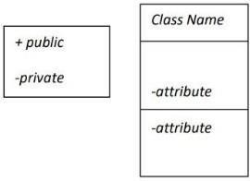 | Represents a collection of similar entities grouped together.
2 | ASSOCIATION | 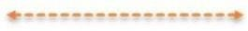 | Associations represent static relationships between classes. Roles represent the way the two classes see each other.
3 | ACTOR | 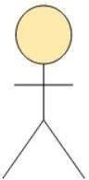 | It aggregates several classes into a single class.
4 | RELATION (uses) | Uses | Used for additional process communication.
5 | RELATION (extents) |  | Extends relationship is used when one use case is similar to another use case.

6 | COMMUNICATION |  | Communication between various use cases.
7 | STATE | 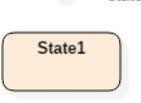 | State of the process
8 | INITIAL STATE |  | Initial state of the object
9 | FINAL STATE |  | Final state of the object
10 | CONTROL FLOW |  | Represents various control flow between the states.
11 | DECISION BOX |  | Represents decision  making process from a  constraint
12 | USE CASE | 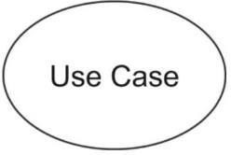 | Interact ion between the system and external environment.

13 | COMPONENT | 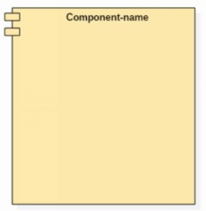 | Represents physical modules which is a collection of components.
14 | NODE | 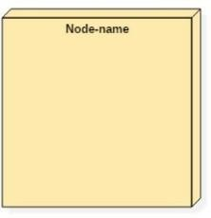 | Represents physical modules which are a collection of components.
15 | DATA PROCESS/ STATE |  | A circle in DFD represents a state or process which has been triggered due to some event or action.
16 | EXTERNAL ENTITY | 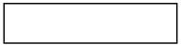 | Represents external entities such as keyboard,  sensors, etc
17 | TRANSITION |  | Represents communication that occurs between processes.
18 | OBJECT LIFELINE | 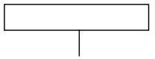 | Represents the vertical dimensions that the object communications.
19 | MESSAGE | 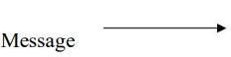 | Represents the message exchanged.

CHAPTER 1

INTRODUCTION

1.1GENERAL

The Real-Time House Price Prediction project is a Python-based application designed to estimate the market value of residential properties accurately. Utilizing advanced machine learning algorithms, particularly linear regression, and extensive datasets, the application provides precise and up-to-date predictions for potential buyers, sellers, and real estate professionals. By integrating real-time data retrieval and processing capabilities, this application offers a dynamic and user-friendly tool for making informed real estate decisions.

The primary objectives of this project include delivering accurate price estimations based on various influential factors such as location, property size, age, and features. It also aims to integrate real-time data feeds to maintain the accuracy of predictions, create a user-friendly interface for easy input and instant results, and ensure scalability and performance to handle high user volumes efficiently. The key features of the application encompass data collection and preprocessing from various sources, a sophisticated machine learning model trained to recognize patterns influencing house prices, and real-time prediction capabilities.

Users can input property details like location, number of bedrooms, and square footage to receive instant price predictions, which are adjusted in real-time based on the latest market trends. The application's web-based interface is developed using Python frameworks such as Flask for backend processing and Jinja2 for frontend rendering, providing an intuitive user experience. Performance optimization through caching and efficient data retrieval strategies ensures quick response times even under heavy load.

Technically, the application comprises a Python and Flask backend for data processing and API management, a Jinja2-based frontend for responsive user interaction, and a relational database (e.g., MySQL, PostgreSQL) for storing data. It integrates external APIs to fetch real-time market listings and economic indicators, while the machine learning model, implemented with libraries such as scikit-learn, utilizes linear regression as its primary algorithm. This model is periodically retrained with new data to maintain its accuracy
Linear regression, a foundational technique in machine learning, is employed to model the relationship between the dependent variable (house price) and one or more independent variables (e.g., square footage, number of bedrooms). By fitting a linear equation to the observed data, the application can predict house prices based on the input features. The simplicity and interpretability of linear regression make it an ideal choice for this application, providing clear insights into how different factors influence property values.

The Real-Time House Price Prediction project offers several benefits, including aiding users in making informed real estate decisions with accurate price estimates, providing market insights, and enhancing efficiency by offering instant predictions. Future enhancements may include more advanced predictive models, geospatial data integration for context-aware predictions, development of a mobile application for better accessibility, and personalized predictions based on user preferences and history.

1.2 PROBLEM STATEMENT
The real estate market is characterized by its dynamic and multifaceted nature, influenced by a myriad of factors that affect property prices. Accurately predicting house prices is a critical task for various stakeholders, including real estate agents, investors, homebuyers, and policymakers. However, the challenge lies in the complexity of the factors involved, such as location, property size, number of rooms, age of the property, and market conditions, which necessitate advanced analytical techniques to interpret.
The primary objective of this project is to develop a robust machine learning model capable of accurately predicting the sale prices of residential properties. By utilizing historical housing data and incorporating relevant features, the project aims to identify significant patterns and relationships that influence property values. The ultimate goal is to provide a reliable tool that can assist in making informed decisions in the real estate market, thereby reducing uncertainty and enhancing the efficiency of the property valuation process.
Key challenges addressed in this project include handling missing data, encoding categorical variables, normalizing numerical features, and selecting the most appropriate predictive algorithms. The project will evaluate various machine learning models, including linear regression, to determine the most effective approach for house price prediction.

1.3 EXISTING SYSTEM
Existing systems for house price prediction leverage a blend of traditional statistical methods and modern machine learning algorithms to estimate property values accurately. Traditional methods like linear regression and multiple regression analysis model the relationship between house prices and various features such as size, location, and amenities. In contrast, advanced machine learning techniques, including decision trees, random forests, gradient boosting machines, and neural networks, capture complex, non-linear relationships within the data. Automated Valuation Models (AVMs), widely used in the real estate industry, combine these approaches to provide quick and reliable property valuations. While these systems have achieved significant success, challenges remain in data quality, feature selection, and market volatility, which can impact prediction accuracy.

1.3.1 DISADVANTAGES OF EXISTING SYSTEM
Data Quality and Availability: Incomplete or outdated data can lead to inaccurate predictions.
Feature Selection: Identifying relevant features is challenging and time-consuming.
Model Complexity: Advanced models require significant computational resources and expertise.
Market Volatility: Rapid changes in the housing market can make historical data less predictive.
Overfitting: Models may overfit training data, leading to poor performance on new data.
Bias and Fairness: Models can inadvertently learn and perpetuate biases from training data.
Interpretability: Complex models often lack transparency, making predictions hard to understand.
Dependence on Historical Data: Reliance on historical data limits the model's ability to account for new trends.
Scalability: Some models may not scale well with large datasets.

1.3 PROPOSED SYSTEM
The proposed system integrates comprehensive datasets with machine learning techniques to enhance house price prediction accuracy. Key features include robust data preprocessing, advanced feature engineering, and the selection of optimal models such as Random Forests and Gradient Boosting Machines. Real-time data integration and bias mitigation strategies ensure reliability and fairness in predictions. A user-friendly interface and continuous model monitoring support practical application and adaptation to market changes, aiming for transparent and accurate house price estimates.

1.4.1 ADVANTAGES OF PROPOSED SYSTEM
• Enhanced Prediction Accuracy: Integrating advanced machine learning techniques and comprehensive datasets improves the accuracy of house price predictions.
• Robust Data Handling: Robust preprocessing and feature engineering techniques ensure data quality and enhance model performance.
• Real-time Adaptation: Integration of real-time data allows the model to adapt quickly to changing market conditions, improving prediction reliability.
• Bias Mitigation: Implementation of fairness-aware algorithms reduces biases in predictions, promoting equitable outcomes.
• User-Friendly Interface: Intuitive interface and insightful visualizations enhance usability and transparency for stakeholders.
•

CHAPTER 2

LITERATURE SURVEY

2.1 MACHINE LEARNING APPROACH FOR HOUSE PRICE PREDICTION

Authors: Mudavath Jagan Chowhaan , Sreevidya Nelli
Abstract: In our ecosystem, real estate is clearly a distinct industry. Predicting house prices, significant housing characteristics, and many other things is made a lot easier by the capacity to extract data from raw data and extract essential information. Daily fluctuations in housing costs are still present, and they occasionally rise without regard to calculations. According to research, changes in property prices frequently have an impact on both homeowners and the real estate market. To analyze the key elements and the best predictive models for home prices, literature research is conducted. The analyses' findings supported the usage of artificial neural networks, support vector regression, and linear regression as the most effective modeling techniques. Our results also imply that real estate agents and geography play important roles in determining property prices. Finding the most crucial factors affecting housing prices and identifying the best machine learning model to utilize for this research would both be greatly aided by this study, especially for housing developers and researchers.

2.2 HOUSING PRICE PREDICTION VIA IMPROVED MACHINE LEARNING TECHNIQUES

Authors: Quang Truong, Minh Nguyen, HyDang, Bo Mei
Abstract: House Price Index (HPI) is commonly used to estimate the changes in housing price. Since housing price is strongly correlated to other factors such as location, area, population, it requires other information apart from HPI to predict individual housing price. There has been a considerably large number of papers adopting traditional machine learning approaches to predict housing prices accurately, but they rarely concern about the performance of individual models and neglect the less popular yet complex models. As a result, to explore various impacts of features on prediction methods, this paper will apply both traditional and advanced machine learning approaches to investigate the difference among several advanced models. This paper will also comprehensively validate multiple techniques in model implementation on regression and provide an optimistic result for housing price prediction

2.3 HOUSE PRICE PREDICTION USING MACHINE LEARNING

Authors: Vaishnavi Aghav, Dhanashree Avhad, Supriya Nanaware, Rakesh Gudekar, Prof. Mahendra Pawar
Abstract: House price prediction using machine learning is a popular topic in the field of data science and artificial intelligence. With the increasing availability of data and the advancements in the machine learning algorithms, predicting house prices accurately has become more feasible than ever before. In this study, we aim to predict house prices using variety of machine learning techniques decision tree, Lasso, Linear regression analysis. We will also explore feature selection and engineering techniques to identify the most important variables that influence house prices. By analyzing and predicting house prices accurately, we can provide valuable insights for buyers, sellers, and real estate agents, enabling them to make informed decisions based on the current market conditions. Our results show that machine learning algorithms can accurately predict house prices and out perform traditional regression methods

2.4 HOUSING PRICE PREDICTION BASED ON MULTIPLE LINEAR REGRESSION

Authors: Punit gupta
Abstract: In this paper, the author first analyzes the major factors affecting housing prices with Spearman correlation coefficient, selects significant factors influencing general housing prices, and conducts a combined analysis algorithm. Then, the author establishes a multiple linear regression model for housing price prediction and applies the data set of real estate prices in Boston to test the method. Through the data analysis and test in this paper, it can be summarized that the multiple linear regression model can effectively predict and analyze the housing price to some extent, while the algorithm can still be improved through more advanced machine learning methods

.2.5 EFFECTIVE HOUSE PRICE PREDICTION USING MACHINE LEARNING

Authors: Jincheng Zhou , Tao Hai , Ezinne C.Maxwell-Chigozie

Abstract: Visual cryptography is a new cryptographic technique which allows visual information (pictures, text, etc.) to be encrypted in such a way that the decryption can be performed by human, without any decryption algorithm. Here we propose a data hiding in halftone images using conjugate ordered dithering (DHCOD) algorithm which is a modified version of data hiding in halftone images using conjugate error diffusion technique (DHCED). We use this DHOCD algorithm for proposing a new three phase visual cryptography scheme. DHCOD technique is used to hide an binary visual pattern in two or more ordered dither halftone images, which can be from the same or different multi-tone images. In proposed scheme we shall generate the shares using basic visual cryptography model and then embed them into a cover image using a DHCOD technique, so that the shares will be more secure and meaningful.

CHAPTER 3

TECHNICAL REQUIREMENTS

3.1 GENERAL

These are the requirements for doing the project.
They are:
- Hardware Requirements
- Software Requirements

3.2 HARDWARE REQUIREMENTS

The hardware requirements may serve as the basis for a contract for the implementation of the system and should therefore be a complete and consistent specification of the whole system. They are used by software engineers as the starting point for the system design. It should be what the system does and not how it should be implemented.

Minimum hardware requirements are very dependent on the particular software being developed by a given Enthought Python / VS Code user. Applications that need to store large arrays/objects in memory will require more RAM, whereas applications that need to perform numerous calculations or tasks more quickly will require a faster processor.

- CPU : intel core i7 or i9
- Ram : Atleast 8 gb (preferably 16 gb)
- Hard disk : SSD’s over HDD’s

3.3 SOFTWARE REQUIREMENTS

The software requirements document is the specification of the system. It should include both a definition and a specification of requirements. It is a set of what the system should do rather than how it should do it. The software requirements provide a basis for creating the software requirements specification. It is useful in estimating cost, planning team activities, performing tasks and tracking the teams and tracking the team’s progress throughout the development activity.

The functional requirements or the overall description documents include the product perspective and features, operating system and operating environment, graphics requirements, design constraints and user documentation.

The appropriation of requirements and implementation constraints gives the general overview of the project in regards to what the areas of strength and deficit are and how to tackle them.

- Python IDE : Python IDE 3.6 or higher version
- Operating System : Windows OS or macOS or linux
- Frontend Technologies : HTML,CSS,Java Script
- Database Management System : MySQL,PostgreSQL or MongoDB

CHAPTER-4

SYSTEM DESIGN

4.1 GENERAL

System design is the process of designing the elements of a system such as the architecture, modules and components, the different interfaces of those components and the data that goes through that system. System Analysis is the process that decomposes a system into its component pieces for the purpose of defining how well those components interact to accomplish the set requirements. The purpose of the System Design process is to provide sufficient detailed data and information about the system and its system elements to enable the implementation consistent with architectural entities as defined in models and views of the system architecture.

The feasibility of the project is analyzed in this phase and business proposal is put forth with a very general plan for the project and some cost estimates. During system analysis the feasibility study of the proposed system is to be carried out. This is to ensure that the proposed system is not a burden to the company. For feasibility analysis, some understanding of the major requirements for the system is essential.

Three key considerations involved in the feasibility analysis are

• ECONOMICAL FEASIBILITY
• TECHNICAL FEASIBILITY
• SOCIAL FEASIBILITY

- ECONOMICAL FEASIBILITY

This study is carried out to check the economic impact that the system will have on the organization. The amount of fund that the company can pour into the research and development of the system is limited.
The expenditures must be justified. Thus the developed system as well within the budget and this was achieved because most of the technologies used are freely available. Only the customized products had to be purchased.

- TECHNICAL FEASIBILITY

This study is carried out to check the technical feasibility, that is, the technical requirements of the system. Any system developed must not have a high demand on the available technical resources. This will lead to high demands on the available technical resources. This will lead to high demands being placed on the client. The developed system must have a modest requirement, as only minimal or null changes are required for implementing this system.

- SOCIAL FEASIBILITY

The aspect of study is to check the level of acceptance of the system by the user. This includes the process of training the user to use the system efficiently. The user must not feel threatened by the system, instead must accept it as a necessity. The level of acceptance by the users solely depends on the methods that are employed to educate the user about the system and to make him familiar with it. His level of confidence must be raised so that he is also able to make some constructive criticism, which is welcomed, as he is the final user of the system.

4.2 SYSTEM ARCHITECTURE
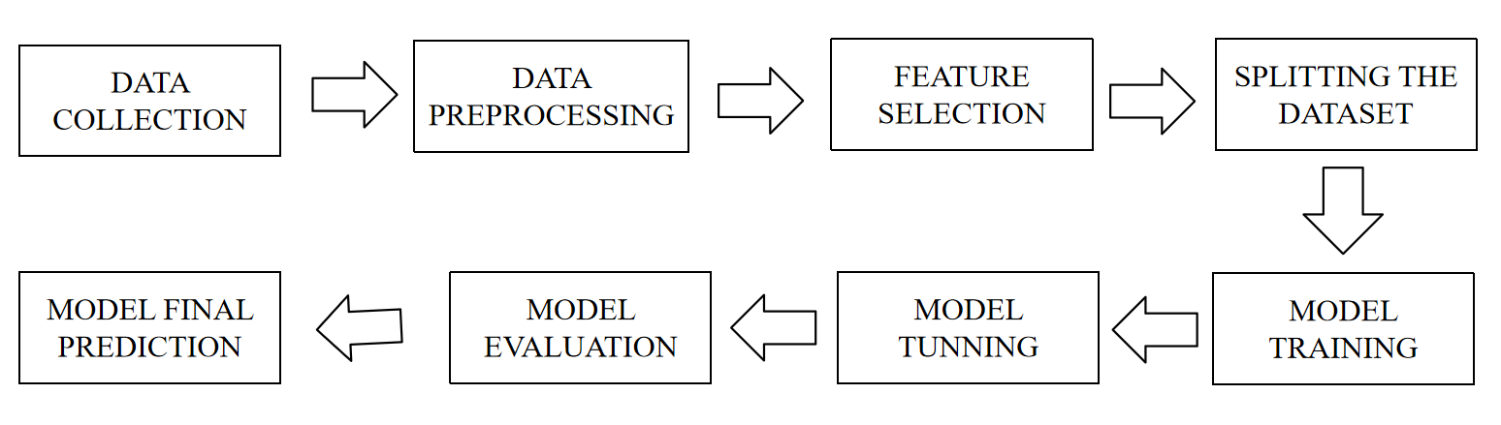
Figure 4.1: Architecture Diagram

4.3 UML DESIGN

Unified Modeling Language (UML) is a general purpose modeling language. The main aim of UML is to define a standard way to visualize the way a system has been designed.
It is quite similar to blueprints used in other fields of engineering.

UML is not a programming language; it is rather a visual language.Use UML diagrams to portray the behavior and structure of a system, UML helps software engineers, businessmen and system architects with modeling, design and analysis.

It’s been managed by OMG ever since. International Organization for Standardization (ISO) published UML as an approved standard in 2005. UML has been revised over the years and is reviewed periodically.

UML combines best techniques from data modeling (entity relationship diagrams), business modeling (work flows), object modeling, and component modeling. It can be used with all processes, throughout the software development life cycle, and across different implementation technologies.

UML has synthesized the notations of the Booch method, the Object-modeling technique (OMT) and Object-oriented software engineering (OOSE) by fusing them into a single, common and widely usable modeling language. UML aims to be a standard modeling language which can model concurrent and distributed systems.

The Unified Modeling Language (UML) is used to specify, visualize, modify, construct and document the artifacts of an object-oriented software intensive system under development. UML offers a standard way to visualize a system's architectural blueprints, including elements such as: ▪ Actors ▪ Business processes ▪ (logical) Components ▪ Activities ▪ Programming Language Statements ▪ Database Schemes ▪
Reusable software components.

- Complex applications need collaboration and planning from multiple teams and hence require a clear and concise way to communicate amongst them.
- Businessmen do not understand code. So UML becomes essential to communicate with non-programmer's essential requirements, functionalities and processes of the system.
- A lot of time is saved down the line when teams are able to visualize processes, user interactions and static structure of the system.
- UML is linked with object oriented design and analysis. UML makes the use of elements and forms associations between them to form diagrams. Diagrams in UML can be broadly classified as:

The Primary goals in the design of the UML are as follows

- Provide users a ready-to-use, expressive visual modeling Language so that they can develop and exchange meaningful models.
- Provide extendibility and specialization mechanisms to extend the core concepts.
- Be independent of particular programming languages and development processes.
- Provide a formal basis for understanding the modeling language.
- Encourage the growth of the OO tools market.
- Support higher level development concepts such as collaborations, frameworks, patterns and components.
- Integrate best practices.

4.3.1 USE-CASE DIAGRAM

A Use Case is a kind of behavioral classifier that represents a declaration of an offered behavior.
Each use case specifies some behavior, possibly including variants that the subject can perform in collaboration with one or more actors. Use cases define the offered behavior of the subject without reference to its internal structure.

These behaviors, involving interactions between the actor and the subject, may result in changes to the state of the subject and communications with its environment. A use case can include possible variations of its basic behavior, including exceptional .

The primary components of a use case diagram include:

- Actor
An actor is an external entity that interacts with the system. Actors can be people, other systems, or even hardware devices. Actors are represented as stick figures or simple icons.
They are placed outside the system boundary, typically on the left or top of the diagram.

- Use Case
A use case represents a specific functionality or action that the system can perform in response to an actor's request. Use cases are represented as ovals within the system boundary.
The name of the use case is written inside the oval.

- Association Relationship
An association relationship is a line connecting an actor to a use case. It represents the interaction or communication between an actor and a use case.
The arrowhead indicates the direction of the interaction, typically pointing from the actor to the use cas

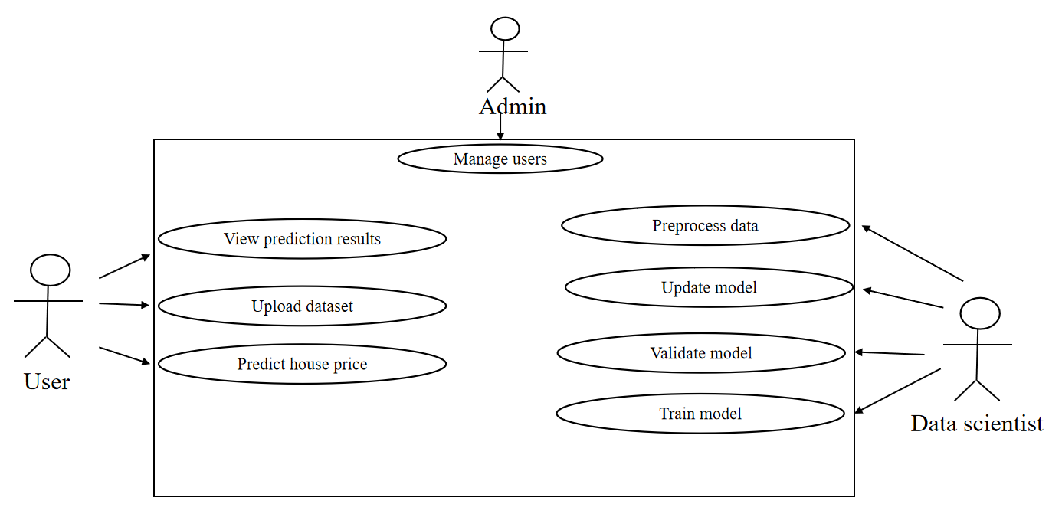

Figure 4.2: Use-Case-Diagram

4.3.2 CLASS DIAGRAM
A class diagram in Unified Modeling Language (UML) is a type of structural diagram that represents the static structure of a system by depicting the classes, their attributes, methods, and the relationships between them. Class diagrams are fundamental in object-oriented design and provide a blueprint for the software's architecture.

Here are the key components and notations used in a class diagram:

- Class
A class represents a blueprint for creating objects. It defines the properties (attributes) and behaviors (methods) of objects belonging to that class.Classes are depicted as rectangles with three compartments: the top compartment contains the class name, the middle compartment lists the class attributes, and the bottom compartment lists the class methods.

- Attributes
Attributes are the data members or properties of a class, representing the state of objects. Attributes are shown in the middle compartment of the class rectangle and are typically listed as a name followed by a colon and the data type (e.g., name: String).

- Methods
Methods represent the operations or behaviors that objects of a class can perform. Methods are listed in the bottom compartment of the class rectangle and include the methodname, parameters, and the return type (e.g., calculateCost(parameters):
ReturnType).

- Visibility Notations
Visibility notations indicate the access level of attributes and methods. The common notations are:
+ (public): Accessible from anywhere.
- (private): Accessible only within the class.
# (protected): Accessible within the class and its subclasses.
~ (package or default): Accessible within the package.

- Associations
Associations represent relationships between classes, showing how they are connected. Associations are typically represented as a solid line connecting two classes. They may have multiplicity notations at both ends to indicate how many objects of each class can participate in the relationship (e.g., 1..*).
Aggregations and Compositions: Aggregation and composition are special types of associations that represent whole-part relationships. Aggregation is denoted by a hollow diamond at the diamond end, while composition is represented by a filled diamond. Aggregation implies a weaker relationship, where parts can exist independently, while composition implies a stronger relationship, where parts are dependent on the whole.
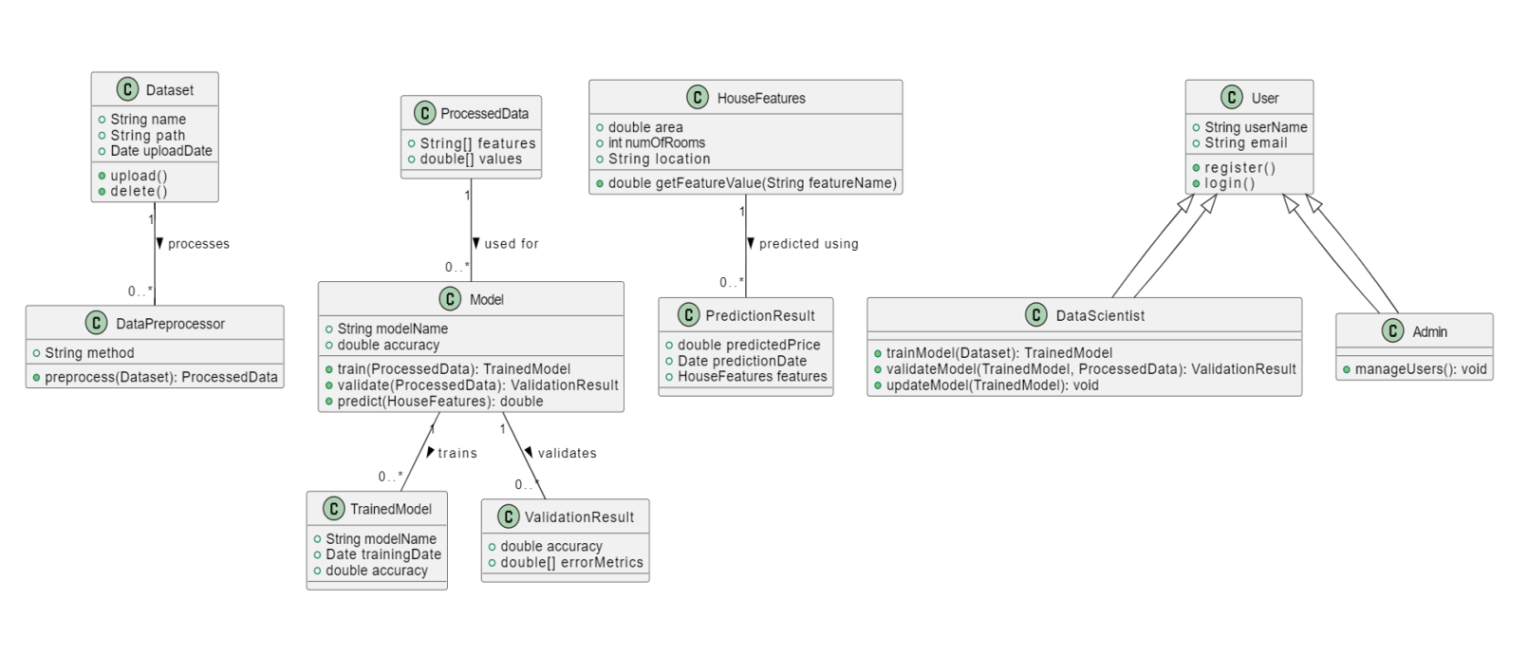
Figure 4.3: Class diagram

4.3.3 ACTIVITY DIAGRAM

An activity diagram portrays the control flow from a start point to a finish point showing the various decision paths that exist while the activity is being executed.

The diagram might start with an initial activity such as "User approaches the door." This activity triggers the system to detect the presence of the user's Bluetooth-enabled device, initiating the authentication process.
Next, the diagram could depict a decision point where the system determines whether the detected device is authorized. If the device is recognized as authorized, the diagram would proceed to the activity "Unlock the door." Conversely, if the device is not authorized, the diagram might show alternative paths such as prompting the user for additional authentication credentials or denying access.

The key components and notations used in an activity diagram:

- Initial Node
An initial node, represented as a solid black circle, indicates the starting point of the activity diagram. It marks where the process or activity begins.

- Activity/Action
An activity or action represents a specific task or operation that takes place within the system or a process. Activities are shown as rectangles with rounded corners. The name of the activity is placed inside the rectangle.

- Control Flow Arrow
Control flow arrows, represented as solid arrows, show the flow of control from one activity to another. They indicate the order in which activities are executed.

- Decision Node
A decision node is represented as a diamond shape and is used to model a decision point or branching in the process. It has multiple outgoing control flow arrows, each labeled with a condition or guard, representing the possible paths the process can take based on condition.

- Merge Node
A merge node, also represented as a diamond shape, is used to show the merging of multiple control flows back into a single flow.

- Fork Node
A fork node, represented as a black bar, is used to model the parallel execution of multiple activities or branches. It represents a point where control flow splits into multiple concurrent paths.

- Join Node
A join node, represented as a black bar, is used to show the convergence of multiple control flows, indicating that multiple paths are coming together into a single flow.

- Final Node
A final node, represented as a solid circle with a border, indicates the end point of the activity diagram. It marks where the process or activity concludes.
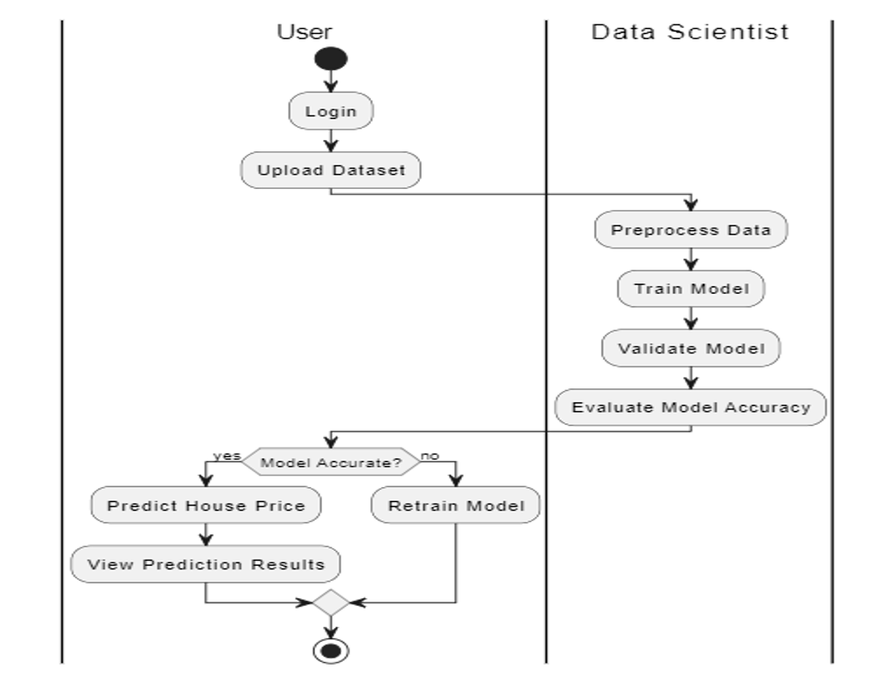

Figure 4.4: Activity diagram

CHAPTER-5
TECHNOLOGY DESCRIPTION

WHAT IS PYTHON

Python is currently the most widely used multi-purpose, high-level programming language. Python allows programming in Object-Oriented and Procedural paradigms. Python programs generally are smaller than other programming languages like Java.
Programmers have to type relatively less and indentation requirement of the language, makes them readable all the time. Python language is being used by almost all tech-giant companies like – Google, Amazon, Facebook, Instagram, Dropbox, Uber… etc.
The biggest strength of Python is huge collection of standard library which can be used for the following –
- Machine Learning
- GUI Applications (like Kivy, Tkinter, PyQt etc. )
- Web frameworks like Django (used by YouTube, Instagram, Dropbox)
- Image processing (like Opencv, Pillow)
- Web scraping (like Scrapy, BeautifulSoup, Selenium)
- Test frameworks
- Multimedia
Python is an interpreted, object-oriented, high-level programming language with dynamic semantics. Its high-level built in data structures, combined with dynamic typing and dynamic binding, make it very attractive for Rapid Application Development, as well as for use as a scripting or glue language to connect existing components together. Python's simple, easy to learn syntax emphasizes readability and therefore reduces the cost of program maintenance. Python supports modules and packages, which encourages program modularity and code reuse. The Python interpreter and the extensive standard library are available in source or binary form without charge for all major platforms, and can be freely distributed. Often, programmers fall in love with Python because of the increased productivity it provides.

Since there is no compilation step, the edit-test-debug cycle is incredibly fast. Debugging Python programs is easy: a bug or bad input will never cause a segmentation fault. Instead, when the interpreter discovers an error, it raises an exception. When the program doesn't catch the exception, the interpreter prints a stack trace. A source level debugger allows inspection of local and global variables, evaluation of arbitrary expressions, setting breakpoints, stepping through the code a line at a time, and so on. The debugger is written in Python itself, testifying to Python's introspective power. On the other hand, often the quickest way to debug a program is to add a few print statements to the source: the fast edit-test-debug cycle makes this simple approach very effective.

Python is a dynamic, high-level, free open source, and interpreted programming language. It supports object-oriented programming as well as procedural-oriented programming. In Python, don’t need to declare the type of variable because it is a dynamically typed language. For example, x = 10 Here, x can be anything such as String, int, etc.

5.2 ADVANTAGES OF PYTHON

- Free and Open Source

Python language is freely available at the official website and you can download it from the given download link below click on the Download Python keyword. Download Python Since it is open-source, this means that source code is also available to the public.
So you can download it, use it as well as share it.

- Easy to code

Python is a high-level programming language. Python is very easy to learn the language as compared to other languages like C, C#, Javascript, Java, etc. It is very easy to code in the Python language and anybody can learn Python basics in a few hours or days.
It is also a developer-friendly language.

- Easy to Read

As you will see, learning Python is quite simple. As was already established, Python’s syntax is really straightforward. The code block is defined by the indentations rather than by semicolons or brackets.

- Object-Oriented Language

One of the key features of Python is Object-Oriented programming. Python supports object-oriented language and concepts of classes, object encapsulation, etc.

- GUI Programming Support

Graphical User interfaces can be made using a module such as PyQt5, PyQt4, wxPython, or Tk in python. PyQt5 is the most popular option for creating graphical apps with Python.

- High-Level Language

Python is a high-level language. When we write programs in Python, we do not need to remember the system architecture, nor do we need to manage the memory.

- Extensible feature

Python is an Extensible language. We can write some Python code into C or C++ language and also we can compile that code in C/C++ language.

- Easy to Debug

Excellent information for mistake tracing. You will be able to quickly identify and correct the majority of your program’s issues once you understand how to interpret Python’s error traces. Simply by glancing at the code, you can determine what it is designed to perform.

- Python is a Portable language

Python language is also a portable language. For example, if we have Python code for windows and if we want to run this code on other platforms such as Linux, Unix, and Mac then we do not need to change it, we can run this code on any platform.

- Python is an Integrated language

Python is also an Integrated language because we can easily integrate Python with other languages like C, C++, etc.

- Interpreted Language

Python is an Interpreted Language because Python code is executed line by line at a time. like other languages C, C++, Java, etc. there is no need to compile Python code this makes it easier to debug our code. The source code of Python is converted into an immediate form called bytecode.

- Large Standard Library

Python has a large standard library that provides a rich set of modules and functions so you do not have to write your own code for every single thing. There are many libraries present in Python such as regular expressions, unit-testing, web browsers, etc.

- Dynamically Typed Language

Python is a dynamically-typed language. That means the type (for example- int, double, long, etc.) for a variable is decided at run time not in advance because of this feature we don’t need to specify the type of variable.

- Frontend and backend development

With a new project py script, you can run and write Python codes in HTML with the help of some simple tags <py-script>, <py-env>, etc.
This will help you do frontend development work in Python like javascript. Backend is the strong forte of Python; it's extensively used for this work because of its frameworks like Django and Flask.

- Allocating Memory Dynamically

In Python, the variable data type does not need to be specified. The memory is automatically allocated to a variable at runtime when it is given a value. Developers do not need to write int y = 18 if the integer value 15 is set to y. You may just type y=18.

5.3 LIBRARIES

- Tensorflow
TensorFlow is a free and open-source software library for dataflow and differentiable programming across a range of tasks. It is a symbolic math library, and is also used for machine learning applications such as neural networks. It is used for both research and production at Google. TensorFlow was developed by the Google Brain team for internal Google use. It was released under the Apache 2.0 open-source license on November 9, 2015.
- Numpy
Numpy is a general-purpose array-processing package. It provides a high-performance multidimensional array object, and tools for working with these arrays. It is the fundamental package for scientific computing with Python. It contains various features including these important ones:
❖ A powerful N-dimensional array object
❖ Sophisticated (broadcasting) functions
❖ Tools for integrating C/C++ and Fortran code
❖ Useful linear algebra, Fourier transform, and random number capabilities

Besides its obvious scientific uses, Numpy can also be used as an efficient multidimensional container of generic data. Arbitrary data-types can be defined using Numpy which allows Numpy to seamlessly and speedily integrate with a wide variety of databases.

- Pandas

Pandas is an open-source Python Library providing high-performance data manipulation and analysis tool using its powerful data structures. Python was majorly used for data munging and preparation. It had very little contribution towards data analysis. Pandas solved this problem. Using Pandas, we can accomplish five typical steps in the processing and analysis of data, regardless of the origin of data load, prepare, manipulate, model, and analyze. Python with Pandas is used in a wide range of fields including academic and commercial domains including finance, economics, Statistics, analytics, etc.

- Matplotlib

Matplotlib is a Python 2D plotting library which produces publication quality figures in variety of hardcopy formats and interactive environments across platforms. Matplotlib can be used in Python scripts, the Python and IPython shells, the Jupyter Notebook, web application servers, and four graphical user interface toolkits. Matplotlib tries to make easy things easy and hard things possible. You can generate plots, histograms, power spectra, bar charts, error charts, scatter plots, etc., with just a few lines of code. For examples, see the sample plots and thumbnail gallery.
For simple plotting the pyplot module provides a MATLAB-like interface, particularly when combined with IPython. For the power user, you have full control of line styles, font properties, axes properties, etc, via an object oriented interface or via a set of functions familiar to MATLAB users.
- Scikit – learn
Scikit-learn provides a range of supervised and unsupervised learning algorithms via a consistent interface in Python. It is licensed under a permissive simplified BSD license and is distributed under many Linux distributions, encouraging academic and commercial use.

5.4 DISADVANTAGES OF PYTHON

So far, we’ve seen why Python is a great choice for your project. But if you choose it, you should be aware of its consequences as well. Let’s now see the downsides of choosing Python over another language.

- Speed Limitations

We have seen that Python code is executed line by line. But since Python is interpreted, it often results in slow execution. This, however, isn’t a problem unless speed is a focal point for the project. In other words, unless high speed is a requirement, the benefits offered by Python are enough to distract us from its speed limitations.

- Weak in Mobile Computing and Browsers

While it serves as an excellent server-side language, Python is much rarely seen on the client-side. Besides that, it is rarely ever used to implement smartphone-based applications. One such application is called Carbonnelle.The reason it is not so famous despite the existence of Brython is that it isn’t that secure.

- Design Restrictions

As you know, Python is dynamically-typed. This means that you don’t need to declare the type of variable while writing the code. It uses duck-typing. But wait, what’s that? Well, it just means that if it looks like a duck, it must be a duck. While this is easy on the programmers during coding, it can raise run-time errors.

- Underdeveloped Database Access Layers

Compared to more widely used technologies like JDBC (Java DataBase Connectivity) and ODBC (Open DataBase Connectivity), Python’s database access layers are a bit underdeveloped. Consequently, it is less often applied in huge enterprises.

- Simple

No, we’re not kidding. Python’s simplicity can indeed be a problem. Take my example. I don’t do Java, I’m more of a Python person. To me, its syntax is so simple that the verbosity of Java code seems unnecessary.This was all about the Advantages and Disadvantages of Python Programming Language.

CHAPTER 6

IMPLEMENTATION

6.1 METHODOLOGY

1. Requirement Gathering:
The project will commence with a thorough gathering of requirements, focusing on understanding the objectives and scope of house price prediction. This phase involves defining the specific features and functionalities desired in the prediction model, as well as identifying the target users and their needs. Requirements will be gathered through stakeholder interviews, literature review of similar projects, and analysis of existing market solutions.

2. Data Collection and Analysis:
Following requirement gathering, the project will proceed with comprehensive data collection from diverse sources such as real estate databases, government records, and online listings. The collected data will encompass a wide range of attributes crucial for predicting house prices, including property characteristics (e.g., size, location, amenities), historical sale prices, economic indicators, and demographic information. Data analysis techniques, including exploratory data analysis (EDA) and statistical methods, will be employed to gain insights into the dataset's characteristics and identify initial patterns.

3. System Design:
The system design phase will focus on designing the architecture and components of the house price prediction system. This includes selecting appropriate machine learning algorithms and models based on the project's requirements and data characteristics. Architectural decisions will consider scalability, performance, and integration requirements for deploying the prediction model effectively. Detailed design documentation will be created to outline the system's structure, algorithms chosen, data flow, and interfaces.

4. Implementation:
With the system design in place, the project will move to the implementation phase, where the selected machine learning models and algorithms will be implemented using programming languages and frameworks suitable for data analysis and machine learning, such as Python with libraries like scikit-learn, TensorFlow, or PyTorch. Implementation will also involve data preprocessing steps like cleaning, normalization, feature engineering, and encoding categorical variables to prepare the data for training and evaluation.

5. Testing:
Testing forms a critical part of the SDLC for ensuring the reliability and accuracy of the house price prediction model. The testing phase will involve rigorous evaluation of the implemented models using appropriate evaluation metrics such as mean squared error (MSE), root mean squared error (RMSE), and R-squared. Testing will be conducted with both training and validation datasets to assess model performance, identify potential overfitting or underfitting issues, and fine-tune model parameters accordingly.

6. Deployment and Maintenance:
Upon successful testing and validation, the house price prediction model will be deployed into a production environment. This phase includes setting up the model to receive input data, generating predictions, and providing outputs in a user-friendly format, such as through a web application interface or API. Continuous monitoring and maintenance of the deployed model will be conducted to ensure its performance remains optimal over time. Updates and improvements to the model may be implemented based on feedback, new data availability, or changes in market dynamics.

7. Documentation and Reporting:
Throughout all phases of the SDLC, comprehensive documentation will be maintained. This includes documenting requirements, data sources, system design, implementation details, testing procedures, deployment instructions, and maintenance protocols. A final project report will summarize the methodology, findings, challenges encountered, and recommendations for future enhancements to the house price prediction system.
6.2 SAMPLE CODE
app.py

from flask import Flask,render_template,request
import numpy as np
import pickle
app=Flask(_name_, template_folder='templates')

app = Flask(_name_)
model = pickle.load(open('D:\\flask\\model.pkl', 'rb'))

@app.route("/")
def hello():
return render_template('index.html',data='')

@app.route('/predict', methods=[ 'POST'])
def predict():
val1 = request.form['bedrooms']
val2 = request.form['bathrooms']
val3 = request.form['floors']
val4 = request.form['yr_built']
arr = np.array([val1, val2, val3, val4])
arr = arr.astype(np.float64)
pred = model.predict([arr])

return render_template('index.html', data=int(pred[0]))

if _name=='main_':
app.run(debug=True)

House.py
import pandas as pd
from sklearn.model_selection import train_test_split
from sklearn.linear_model import LinearRegression
import pickle
df = pd.read_csv(
r'D:\\flask\\house_data .csv')
columns = ['bedrooms', 'bathrooms', 'floors', 'yr_built', 'price']
df = df[columns]
X = df.iloc[:, 0:4]
y = df.iloc[:, 4:]
X_train, X_test, y_train, y_test = train_test_split(X, y, test_size=0.25)
lr = LinearRegression()
lr.fit(X_train, y_train)
pickle.dump(lr, open('model.pkl', 'wb'))
Index.html
<!DOCTYPE html>
<html>
<head>
<meta charset='utf-8'>
<meta http-equiv='X-UA-Compatible' content='IE=edge'>
<title>House Price Prediction</title>
<meta name='viewport' content='width=device-width, initial-scale=1'>
<link rel='stylesheet' href="../static/css/style.css">
<script src="../static/js/main.js" defer></script>
</head>
<body>
<h1>HOUSE PRICE PREDICTION</h1>
<div class="register_page">
<div class="form">
<form action="{{url_for('predict')}}" method="POST">
Bedrooms: <input type="number" name='bedrooms' placeholder="Enter the no of Bedrooms"><br>
Bathrooms: <input type="number" name='bathrooms' placeholder="Enter the no of Bathrooms"><br>
Floors: <input type="number" name='floors' placeholder="Enter the no of Floors"><br>
Year of Build: <input type="number" name='yr_built' placeholder="Enter year of Build"><br>
<input type="submit" value="predict" class="submit">
</form>
<p> House Price is: {{data}}</p>
</div>
</div>
</body>
</html>
Style.css
body{
background: #6495ed;
height: 100vh;
}
body h1{
text-align: center;
}

.register_page{
width: 360px;
margin: auto;
}
.form{
position: relative;
z-index: 1;
background: #ffff;
max-width: 360px;
margin: 0 auto 100px;
padding: 45px;
}
.form input{
font-family: 'Times New Roman', Times, serif;
outline: 1;
background: #f2f2f2;
width: 100%;
border: 0;
margin: 0 0 15px;
padding: 15px;
box-sizing: border-box;
font-size: 14px;
}
.submit{
font-size: 15px;
text-transform: uppercase;
font-weight: 600;
color: cornflowerblue;
}
Main.js
document.addEventListener("DOMContentLoaded", function() {
const form = document.querySelector("form");
const bedroomsInput = document.querySelector("input[name='bedrooms']");
const bathroomsInput = document.querySelector("input[name='bathrooms']");
const floorsInput = document.querySelector("input[name='floors']");
const yrBuiltInput = document.querySelector("input[name='yr_built']");
const submitButton = document.querySelector("input[type='submit']");

form.addEventListener("submit", function(event) {
let valid = true;
let errorMessage = "";

if (bedroomsInput.value <= 0) {
valid = false;
errorMessage += "Bedrooms must be greater than 0.\n";
}

if (bathroomsInput.value <= 0) {
valid = false;
errorMessage += "Bathrooms must be greater than 0.\n";
}

if (floorsInput.value <= 0) {
valid = false;
errorMessage += "Floors must be greater than 0.\n";
}

if (yrBuiltInput.value <= 0) {
valid = false;
errorMessage += "Year of Build must be greater than 0.\n";
}

if (!valid) {
event.preventDefault();
alert(errorMessage);
}
});
});

CHAPTER 7
TESTING

7.1 GENERAL

The purpose of testing is to discover errors. Testing is the process of trying to discover every conceivable fault or weakness in a work product. It provides a way to check the functionality of components, sub assemblies, assemblies and/or a finished product. It is the process of exercising software with the intent of ensuring that the Software system meets its requirements and user expectations and does not fail in an unacceptable manner. There are various types of tests. Each test type addresses a specific testing requirement.

Testing for a Multilevel Data Concealing Technique that integrates Steganography and Visual Cryptography is crucial to ensure its functionality, security, and reliability. The testing process involves several stages, including unit testing, integration testing, and security testing.

7.2 TYPES OF TESTING
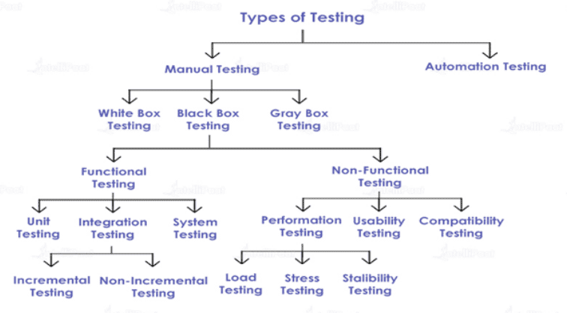
Figure 7.1 Types of Testing

7.3 TEST CASES

Test Case ID | Description | Expected Output | Actual Output | Test Status
T001 | Registration or Sign UP | Registered Successfully | Registered Successfully | Success
T002 | Login or sign in with correct credentials | Logged in the first page of application visible | Logged in the first page of application visible | Success
T002 | Login or sign in with correct credentials | User name or pass word incorrect | User name or pass word incorrect | failure
T004 | User login with incorrect credentials | Logged in the first page of application visible | Logged in the first page of application visible | failure

Table 7.1 Test cases

CHAPTER 8

RESULTS

8.1 SCREEN SHOTS
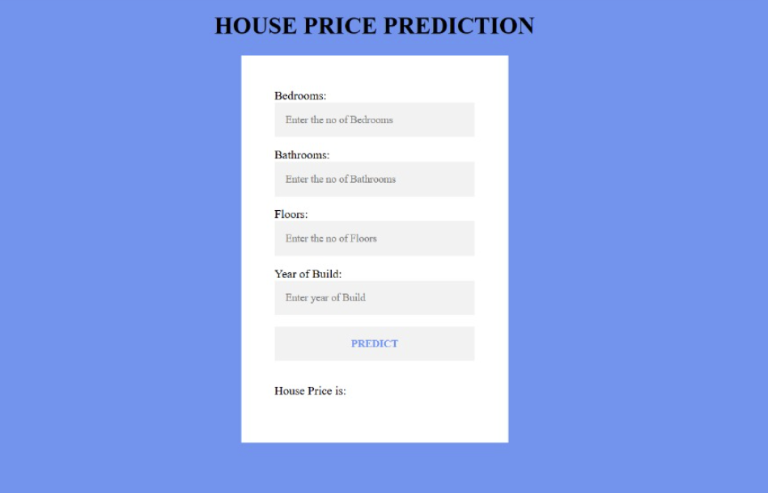

Figure 8.1 Home Page

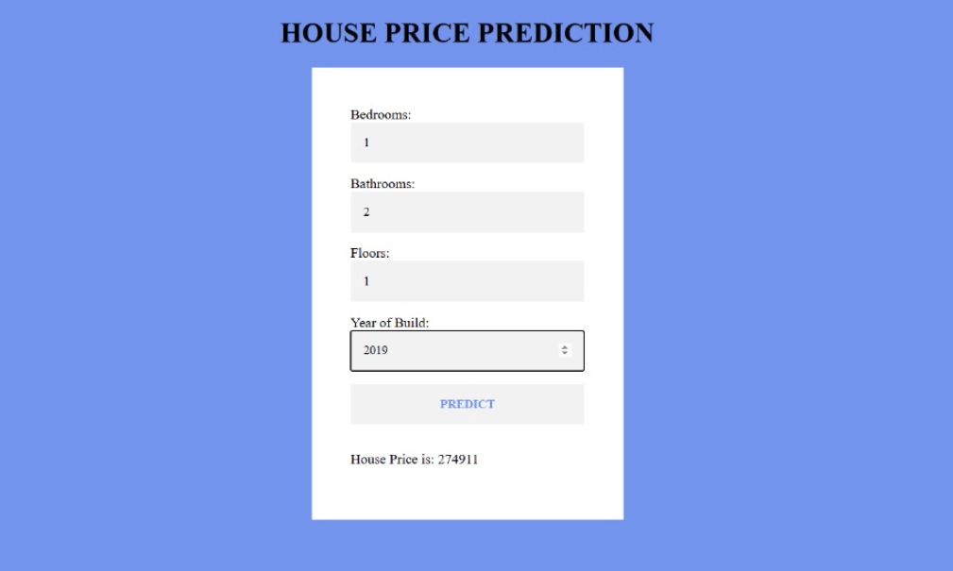

Figure 8.2 valid house price prediction

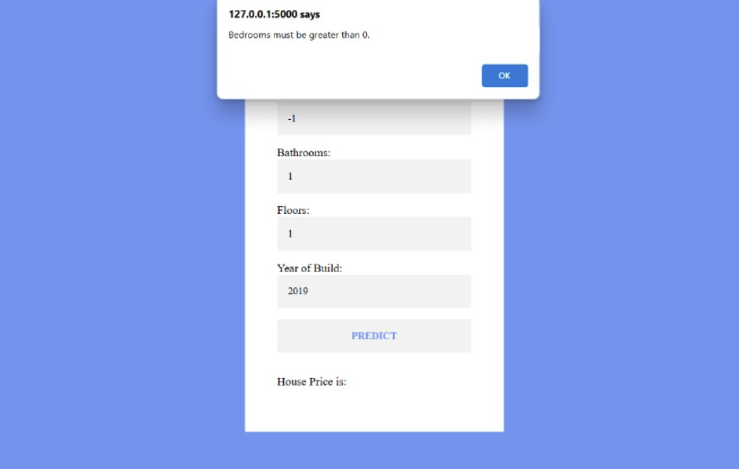
Figure 8.3 invalid inputs

CHAPTER - 9

FUTURE SCOPE

9.1 FUTURE SCOPE
The future scope of a multilevel data concealing technique combining steganography and visual cryptography is promising, especially given the increasing concern for data security and privacy in various fields such as communication, finance, healthcare, and military applications. Here are some potential avenues for future development and application:

- Enhanced Security Measures: As cyber threats continue to evolve, there will be a growing demand for more robust security measures. Multilevel data concealing techniques offer an added layer of security by combining the strengths of steganography and visual cryptography. Future research can focus on enhancing the encryption and hiding algorithms to withstand advanced attacks.
- Application in IoT and Edge Computing: With the proliferation of Internet of Things (IoT) devices and edge computing, there's a need for secure communication and data transmission in decentralized environments. Multilevel data concealing techniques can be adapted for use in IoT networks to protect sensitive information transmitted between devices.
- Privacy Preservation in Cloud Computing: Cloud computing offers scalability and flexibility, but concerns about data privacy and security remain significant barriers to adoption. Multilevel data concealing techniques can be employed to encrypt data before storing it in the cloud, ensuring that sensitive information remains confidential even if the cloud service provider is compromised.
- Biometric Data Security: As biometric authentication becomes more prevalent in various applications, ensuring the security and privacy of biometric data is crucial. Multilevel data concealing techniques can be used to encrypt biometric templates stored in databases or transmitted over networks, preventing unauthorized access or tampering.
- Secure Communication in 5G Networks: The rollout of 5G networks introduces new opportunities and challenges for secure communication. Multilevel data concealing techniques can be integrated into 5G protocols to protect user data from interception and eavesdropping, ensuring end-to-end security in high-speed wireless networks.

CHAPTER-10

CONCLUSION

10.1 CONCLUSION
The proposed method has multiple encryption and decryption processes such as XOR, OTP, steganography, image scrambling and visual Cryptography. All these processes when used individually would give protection but not as much protection as it would give when all of them are combined. It increases confusion as well as diffusion to the unauthorized party. It can be concluded that with the use of multiple cryptographic techniques, it is made difficult for the unauthorized party to get the message. The One-time pad algorithm is one of the most secure type of encryption which makes it impossible to decrypt the code because of the random key used. Thus, the proposed system can withstand any kind of attacks. Using visual cryptography and image scrambling we have been able to enhance the regular image security. This method can be used for implementing video steganography where in the secret message can be encrypted using video as a cover medium..

Throughout our exploration of this technique, it became evident that its effectiveness lies in its ability to seamlessly integrate steganographic embedding, Visual Cryptography, encryption, and decryption mechanisms. By embedding data into cover media using steganography and further enhancing its security through Visual Cryptography and encryption, the technique ensures that concealed data remains confidential and protected from unauthorized access or tampering.

Moreover, our testing efforts, including unit testing, integration testing, system testing, and acceptance testing, have demonstrated the reliability, functionality, and usability of the Multilevel Data Concealing Technique. From validating the accuracy of data embedding and extraction processes to assessing performance under various conditions, our testing approach has confirmed the effectiveness and robustness of the technique in real-world scenarios.

Looking ahead, the Multilevel Data Concealing Technique holds great promise for applications in areas such as data security, digital forensics, and privacy protection. By leveraging the power of steganography and Visual Cryptography, organizations and individuals can conceal sensitive information within digital media with confidence, knowing that their data remains secure and protected from prying eyes.

In conclusion, the Multilevel Data Concealing Technique represents a significant advancement in data concealment and encryption technologies, offering a comprehensive solution for safeguarding sensitive information in an increasingly digital world. As technology continues to evolve, this technique stands as a testament to the ongoing efforts to enhance data security and privacy in the digital age.

CHAPTER-11

REFERENCES

- Natarajan, S., Prema, G.: Steganography using genetic algorithm along with visual cryptography for wireless network application. In: International Conference on Information Communication and Embedded Systems (ICICES) (2013)

- Shao, L., Qin, Z., Liu, B., Qin, J., Li, H.: Image scrambling algorithm based on random shuffling strategy. In: 3rd IEEE International Conference on Industrial Electronics and Applications (ICIEA), Singapore (2008)

- Tseng, L.-Y., Chan, Y.-K., Ho, Y.-A., Chu, Y.-P.: Image hiding with an improved genetic algorithm and an optimal pixel adjustment process. In: Eighth International Conference, vol. 3, on Intelligent Systems Design and Applications (ISDA), Kaohsiung (2008)

- Li, H., Du, W., Yao, X., Wu, H.: A steganographic scheme based on image scrambling and coding techniques. In: International Conference on Communications, Circuits and Systems (ICCCAS) vol. 1, Chengdu, China (2013)

- Blesswin, J., Rema, Joselin, J.: Recovering secret image in visual cryptography. In: International Conference on Communications and Signal Processing (ICCSP), Calicut (2011)

- Jena, D., Jena, S.K.: A novel visual cryptography scheme. In: International Conference on Advance Computer Control (2009)

- Che, S., Che, Z., Ma, B.: An improved image scrambling algorithm. In: Second International Conference on Genetic and Evolutionary Computing (WGEC), Hubei (2008)

- Ghasemi, E., Shanbehzadeh, J., Fassihi, N.: High capacity image steganography using wavelet transform and genetic algorithm. Manuscript received November, 2010; revised (2011)

- Al-Bahadili, H.: A secure block permutation image steganography algorithm. Int. J. Crypt. Inf. Secur. (IJCIS) 3(3) (2013)

- Usha, B.A., Srinath, N.K., Narayan, K., Sangeetha, K.N.: A secure data embedding technique in image steganography for medical images. Int. J. Adv. Res. Comput. Commun. Eng. 3(8) (2014)

- Luo, H., Yu, F., (Correspondence author), Pan, J.-S.: Data hiding in non-expansion visual cryptography based on edge enhancement multitoning. In: The Fourth International Conference on Information Assurance and Security (2008)

- Shang, Z., Ren, H., Zhang, J.: A block location scrambling algorithm of digital image based on arnold transformation. In: The 9th International Conference for Young Computer Scientists (2008)

